*** Suicide***

***and Suicidal Thinking***

|  |  |
| --- | --- |
|  |  |
|  |  |
| Date: | | Saturday March 23rd 2024 | |
| Venue: | | Caterham Community Church CR3 5NF | |
|  | |  | |
| Timings: | | 9.15 am for prompt 9.30 am start, to 4.00 pm.  (6 hours CPD) | |
|  | |  | |
| Training Provider: | | Les Johns  *Les qualified as a social worker, then spent 20 years in the Probation Service before taking early retirement. He has since worked as a counsellor, supervisor and trainer for a further 20 years.*  *His original training was psychodynamic and over the years he has evolved, via many of the major approaches, into the committed person-centred counsellor he now is. However, this CPD is, he believes, relevant to counsellors, and other interested parties, of all persuasions.*  *He is an accredited counsellor and supervisor* | |
|  | |  | |
| Cost: | | £50.00  Light refreshments provided. Please bring your own lunch | |
| To book: | | Please make payment of £50 by bank transfer to:  Caterham Community Church, 40-52-40, 00024447 (Ref CPD & Name)  then confirm by emailing [info@caterhamcounsellingcentre.co.uk](mailto:info@caterhamcounsellingcentre.co.uk). | |
| Queries: | | Dorlisa on 07900 256868 | |

Potential suicide is one of the most challenging situations for a counsellor to encounter. This workshop will offer an opportunity to explore the main issues, and will include:

* The ethical dilemma: sanctity of life or client autonomy?
* Why do people consider taking their own life?
* Risk assessment
* Offering a therapeutic relationship
* 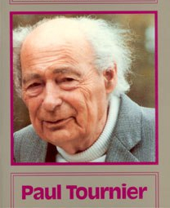Safety plans
* Supervision and Self-Care

‘It is impossible to over-emphasise the immense need humans have to be really listened to, to be taken seriously, to be understood.’

*Dr Paul Tournier*